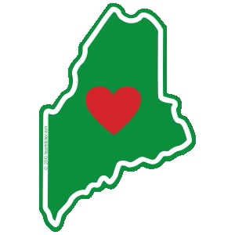
Supporting recovery in workplaces across Maine!

Employer Resources
Maine Department of Labor: Access to training & consultation, recruiting tools, labor laws and statistics, and more. Visit www.maine.gov/labor/
211 Maine: Statewide Resource site. Call 211 or visit www.211maine.org to find resources in your local community.
Regional Workforce Boards:
Northeast Workforce Development Board: www.northeasternwdb.org
Central Western Workforce Board: www.cwmwdb.org
Coastal Counties, Inc.: www.coastalcounties.org

Chamber of Commerce: Connect with your local Chamber of Commerce to access area resources to support workforce. Find your local Chamber here: www.uschamber.com/co/chambers/maine
Recovery Community Centers: Peer led recovery community centers extend recovery support, resources, and connection. Find your local recovery community center learn about the recovery resources in your area. www.maine.gov/future/initiatives/opioids/recoverycenters
OPTIONS: Statewide resource to reduce overdose risk through prevention, intervention and resource connection. Access the local resource finder: www.knowyouroptions.me/resources/
National Safety Council: America’s leading safety advocate, focusing on the areas of workplace, roadways, and impairment. Access to workplace resources, consultation, and training.
Visit www.nsc.org

National Safety Council RFW: Building a Recovery Friendly Workplace

